My Restaurant Website

Augustine Morris

Purdue University Global

**Description**: Describe your restaurant.

Hello friends! Welcome to Dick's Weiner's Bar and Grill!

For over 30 years, we are known for serving only the most premium meats in the area, provided by our award-winning chef. We pride ourselves on quality service and ensuring the customer comes first. With a wide selection of burgers, prime ribeye steak, wings, chicken, and wieners, we know we will have you walking through the door hungry, leave satisfied, and coming back for more! Our bar, tended by only the finest bartenders, is the perfect place for a weekend with the girls or guys as it comes with various liquors, beers on tap, and spirits! Game night does not get any better with our 95-inch 8k TVs! We also provided entertainment for the whole family, including all the most advanced consoles and streaming services up the wazoo! At Dick's Weiner's Bar and Grill, the fun never ends, so join us today!

**Purpose:** What is/are the purpose(s) of my Web site?

The purpose of my website is to introduce customers to our restaurant's premium services, meats, and entertainment.

**Goals:** What are the goals of my web site?

Allow customers to order and pay online for pick-up and delivery.

Allow customers to find Dick’s Weiner’s Bar and Grill via Google Maps or Maps.

Allow customers to find contact information and menus.

**Audience:** Who is my target audience?

Potential customers who want have fun!

Potential customers who are enthusiast for prime meats!

**Color Scheme:** Describe the color scheme you will use on your site.

For the Website background the color will be light blue with black text and yellow headings.

**Layout:** Which layout will you use?

Layout A:

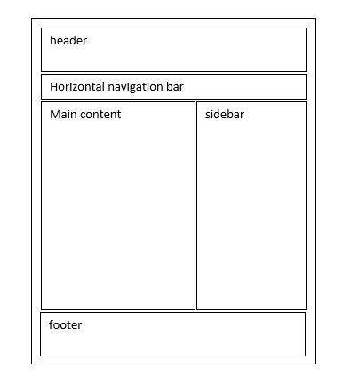

**Content**: Define the content of your website.

Home Page: The Home Page will contain the logo, heading, navigation bar, and test to welcome users to the Website.

About Us Page: The About Us Page will contain text on who we are, information about our prime meats, fantastic service, mission, navigation bar, heading, and the logo.

Menu Page: The Menu Page will contain a wide selection and prices of appetizers, meals, sides, liquor, beers, a game menu for the consoles, the logo, heading, and navigation bar.

Contact Us Page: The Contact Us Page will contain phone number, fax number, email address, Twitter, Facebook, Instagram, Snapchat, Reddit, physical address, the logo, heading, and navigation bar.

Thank You Page: The Thank You Page will contain a text thanking customers for their support, the logo, heading, and navigation bar.

Chef Page: The Chefs Page will contain information about the chef and the chef's training in prime meats and the chef's awards, the logo, heading, and navigation bar.

History Page: The History Page will contain a history of the restaurant, how the restaurant started, the logo, heading, and navigation bar.